**Name: Gaurav Kumar Singh**

**Registration Number: 19BCE2119**

**Course: Web Technology (ITE1002)**

**EXERCISE-1**

**INDEX**

**1 🡪 Page 2**

**2 🡪 Page 7**

**3 🡪 Page 21**

**4 🡪 Page 31**

**5 🡪 Page 35**

**6 🡪 Page 38**

**7 🡪 Page 40**

**8 🡪 Page 46**

**9 🡪 Page 48**

**10 🡪 Page 51**

**11 🡪 Page 55**

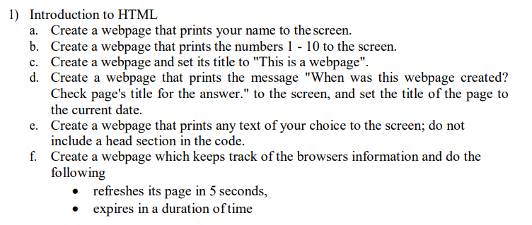

**a.**

**CODE**

<html lang="en">

<head>

    <meta charset="UTF-8">

    <meta http-equiv="X-UA-Compatible" content="IE=edge">

    <meta name="viewport" content="width=device-width, initial-scale=1.0">

    <title>1a</title>

</head>

<body>

    <h3>Gaurav Kumar Singh</h3>

</body>

</html>

**SCREENSHOTS**

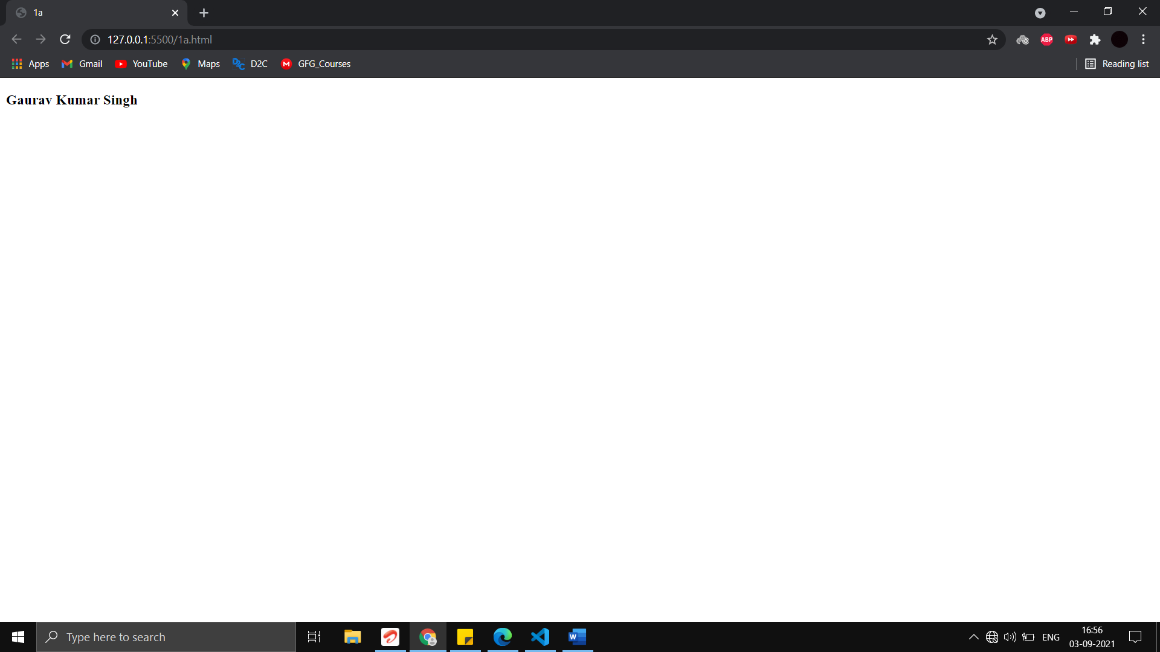

**b.**

**CODE**

<!DOCTYPE html>

<html lang="en">

<head>

    <meta charset="UTF-8">

    <meta http-equiv="X-UA-Compatible" content="IE=edge">

    <meta name="viewport" content="width=device-width, initial-scale=1.0">

    <title>Document</title>

</head>

<body>

    1 2 3 4 5 6 7 8 9 10

</body>

</html>

**SCREENSHOTS**

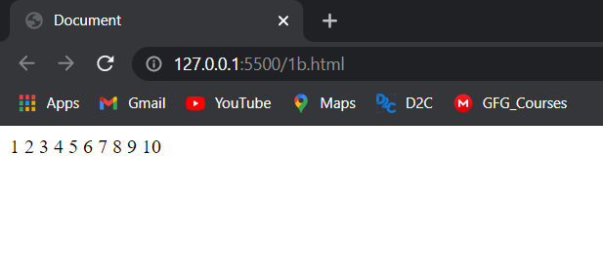

**c.**

**CODE**

<!DOCTYPE html>

<html lang="en">

<head>

    <meta charset="UTF-8">

    <meta http-equiv="X-UA-Compatible" content="IE=edge">

    <meta name="viewport" content="width=device-width, initial-scale=1.0">

    <title>This is a webpage.</title>

</head>

<body>

</body>

</html>

**SCREENSHOTS**

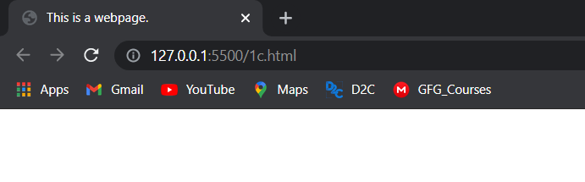

**d.**

**CODE**

<!DOCTYPE html>

<html lang="en">

<head>

    <meta charset="UTF-8">

    <meta http-equiv="X-UA-Compatible" content="IE=edge">

    <meta name="viewport" content="width=device-width, initial-scale=1.0">

    <title>10-August-2021</title>

</head>

<body>

    <p>When was this webpage created? Check page's title for answer.</p>

</body>

</html>

**SCREENSHOTS**

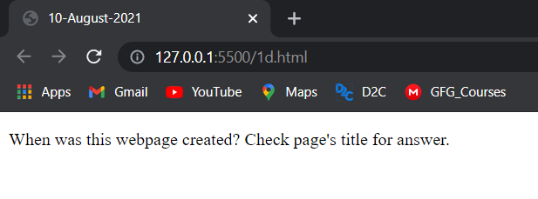

**e.**

**CODE**

<!DOCTYPE html>

<html lang="en">

<body>

    <p>Registration Number: 19BCE2119</p>

</body>

</html>

**SCREENSHOTS**

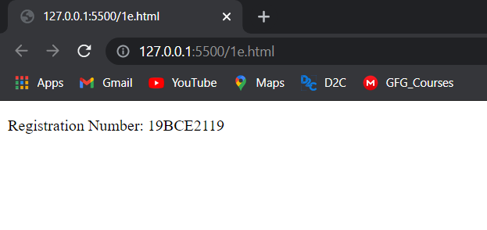

**f.**

**CODE**

<!DOCTYPE html>

<html lang="en">

<head>

    <meta charset="UTF-8">

    <meta http-equiv="X-UA-Compatible" content="IE=edge">

    <meta name="viewport" content="width=device-width, initial-scale=1.0">

    <title>Document</title>

    <meta http-equiv="refresh" content="5">

    <meta name="expire" content="Wed, 11 Aug 2021 19:31:00 GMT">

</head>

<body>

</body>

</html>

**SCREENSHOTS**



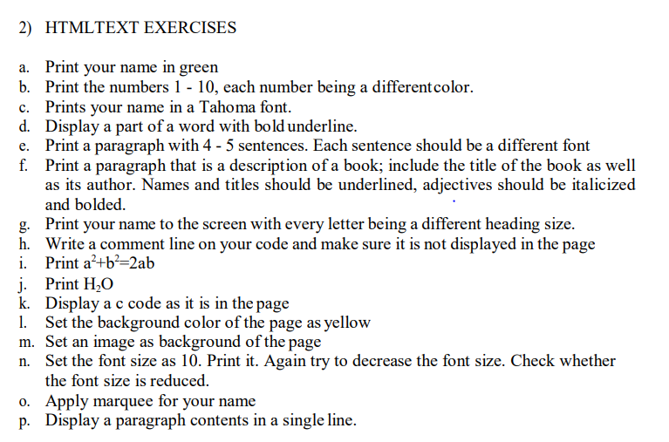

**a.**

**CODE**

<!DOCTYPE html>

<html lang="en">

<head>

    <meta charset="UTF-8">

    <meta http-equiv="X-UA-Compatible" content="IE=edge">

    <meta name="viewport" content="width=device-width, initial-scale=1.0">

    <title>Document</title>

</head>

<body>

    <h3 ><font color="green">

            Gaurav Kumar Singh

        </font></h3>

</body>

</html>

**SCREENSHOTS**



**b.**

**CODE**

<!DOCTYPE html>

<html lang="en">

<head>

    <meta charset="UTF-8">

    <meta http-equiv="X-UA-Compatible" content="IE=edge">

    <meta name="viewport" content="width=device-width, initial-scale=1.0">

    <title>Document</title>

</head>

<body>

    <font color="red">1</font>

    <font color="blue">2</font>

    <font color="green">3</font>

    <font color="black">4</font>

    <font color="grey">5</font>

    <font color="maroon">6</font>

    <font color="turquoise">7</font>

    <font color="cyan">8</font>

    <font color="purple">9</font>

    <font color="dark blue">10</font>

</body>

</html>

**SCREENSHOTS**

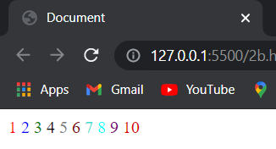

**c.**

**CODE**

<!DOCTYPE html>

<html lang="en">

<head>

    <meta charset="UTF-8">

    <meta http-equiv="X-UA-Compatible" content="IE=edge">

    <meta name="viewport" content="width=device-width, initial-scale=1.0">

    <title>Document</title>

</head>

<body>

    <h3 >

        <font face="Tahoma">

            Gaurav Kumar Singh

        </font>

    </h3>

</body>

</html>

**SCREENSHOTS**

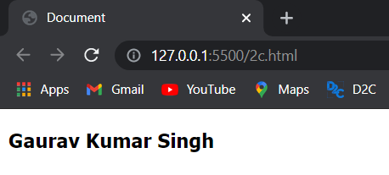

**d.**

**CODE**

<!DOCTYPE html>

<html lang="en">

<head>

    <meta charset="UTF-8">

    <meta http-equiv="X-UA-Compatible" content="IE=edge">

    <meta name="viewport" content="width=device-width, initial-scale=1.0">

    <title>Document</title>

    <style>.ub{

        font-weight: bold;

        text-decoration: underline;

    }

    </style>

</head>

<body>

    1) <u><b>Hello</b></u> using tags

    <p class="ub">2) Hello</p> using style tag

    <p>3) Using external css</p>

</body>

</html>

**SCREENSHOTS**

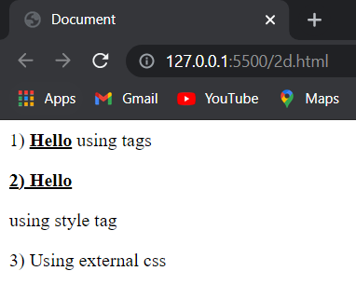

**e.**

**CODE**

<!DOCTYPE html>

<html lang="en">

<head>

    <meta charset="UTF-8">

    <meta http-equiv="X-UA-Compatible" content="IE=edge">

    <meta name="viewport" content="width=device-width, initial-scale=1.0">

    <title>Document</title>

</head>

<body>

    <p>

        <font face="Tahoma">Your skills of writing Paragraph will make you a perfect man. </font>

        <font face="Times New Roman">If you look at any printed prose book, you will see that each chapter is divided up into sections, the first line of each being indented slightly to the right. These sections are called Paragraph. </font>

        <font face="Calibri">Chapters, essays and other prose compositions are broken up into paragraphs, to make the reading of them easier.</font>

        <font face="Verdana">For the beginning of a new paragraph marks a change of topic or a step in the development of an argument or of a story.</font>

        <font face="Robota">In writing essays or other compositions, it is important to know how to divide them properly into paragraphs.</font>

    </p>

</body>

</html>

**SCREENSHOTS**

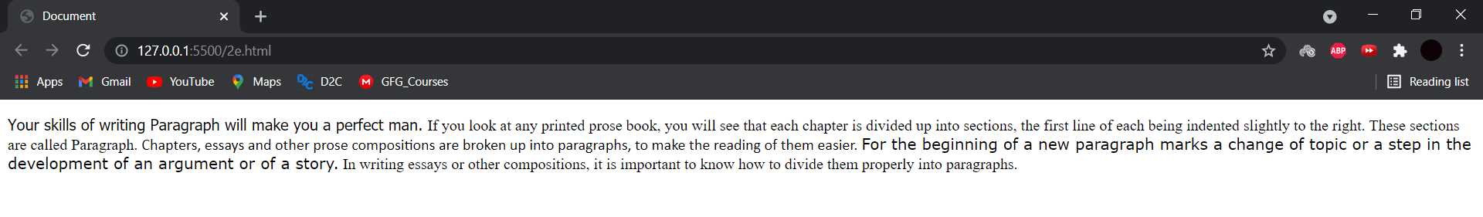

**f.**

**CODE**

<!DOCTYPE html>

<html lang="en">

<head>

    <meta charset="UTF-8">

    <meta http-equiv="X-UA-Compatible" content="IE=edge">

    <meta name="viewport" content="width=device-width, initial-scale=1.0">

    <title>Inferno</title>

</head>

<body>

    <h3>Dan Brown's Inferno</h3>

    <p>‘Seek and ye shall find.’

        With these words echoing in his head, <u>Harvard</u> symbologist <u>Robert Langdon</u> awakes in a hospital bed with no recollection of where he is or how he got there. Nor can he explain the origin of the <i>macabre</i> object that is found hidden in his belongings.

        A threat to his life will propel him and a <i>young</i> doctor, <u>Sienna Brooks</u>, into a breakneck chase across the city of <u>Florence</u>.</p>

</body>

</html>

**SCREENSHOTS**

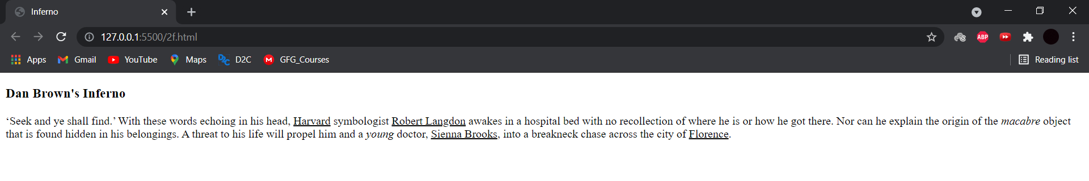

**g.**

**CODE**

<!DOCTYPE html>

<html lang="en">

<head>

    <meta charset="UTF-8">

    <meta http-equiv="X-UA-Compatible" content="IE=edge">

    <meta name="viewport" content="width=device-width, initial-scale=1.0">

    <title>Document</title>

</head>

<body>

    <h1>G</h1><h2>A</h2><h3>U</h3><h4>R</h4><h5>A</h5><h6>V</h6>

</body>

</html>

**SCREENSHOTS**

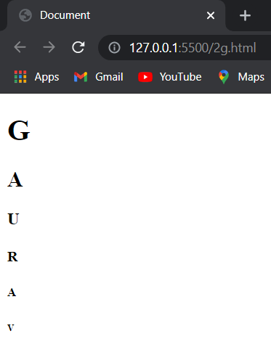

**h.**

**CODE**

<!DOCTYPE html>

<html lang="en">

<head>

    <meta charset="UTF-8">

    <meta http-equiv="X-UA-Compatible" content="IE=edge">

    <meta name="viewport" content="width=device-width, initial-scale=1.0">

    <title>Document</title>

</head>

<body>

    There is a comment after this line in the code.

    <!-- This is the comment -->

</body>

</html>

**SCREENSHOTS**

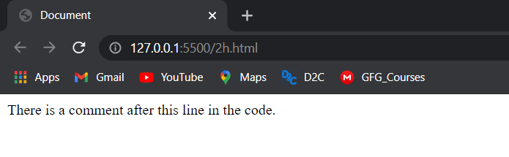

**i.**

**CODE**

<!DOCTYPE html>

<html lang="en">

<head>

    <meta charset="UTF-8">

    <meta http-equiv="X-UA-Compatible" content="IE=edge">

    <meta name="viewport" content="width=device-width, initial-scale=1.0">

    <title>Document</title>

</head>

<body>

    a<sup>2</sup>+b<sup>2</sup>=2ab

</body>

</html>

**SCREENSHOTS**

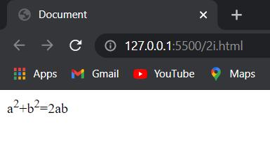

**j.**

**CODE**

<!DOCTYPE html>

<html lang="en">

<head>

    <meta charset="UTF-8">

    <meta http-equiv="X-UA-Compatible" content="IE=edge">

    <meta name="viewport" content="width=device-width, initial-scale=1.0">

    <title>Document</title>

</head>

<body>

    H<sub>2</sub>O

</body>

</html>

**SCREENSHOTS**

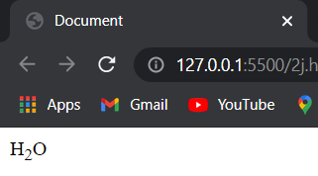

**k.**

**CODE**

<!DOCTYPE html>

<html lang="en">

<head>

    <meta charset="UTF-8">

    <meta http-equiv="X-UA-Compatible" content="IE=edge">

    <meta name="viewport" content="width=device-width, initial-scale=1.0">

    <title>Document</title>

</head>

<body>

    <pre>

    <code>

        #include &#60;stdio.h&#62;

            int main() {

                printf("Hello World");

                return 0;

            }

    </code>

</pre>

</body>

</html>

**SCREENSHOTS**

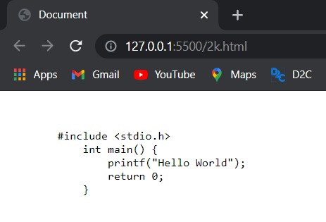

**l.**

**CODE**

<!DOCTYPE html>

<html lang="en">

<head>

    <meta charset="UTF-8">

    <meta http-equiv="X-UA-Compatible" content="IE=edge">

    <meta name="viewport" content="width=device-width, initial-scale=1.0">

    <title>Document</title>

</head>

<body style="background-color:yellow;">

</body>

</html>

**SCREENSHOTS**

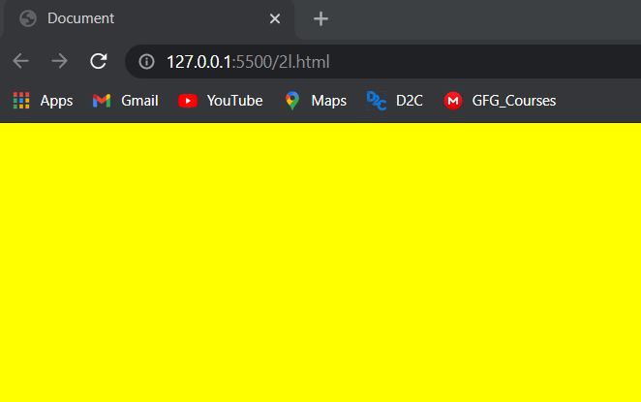

**m.**

**CODE**

<!DOCTYPE html>

<html lang="en">

<head>

    <meta charset="UTF-8">

    <meta http-equiv="X-UA-Compatible" content="IE=edge">

    <meta name="viewport" content="width=device-width, initial-scale=1.0">

    <title>Document</title>

</head>

<body style="background-image:url('Bot_Icon.jpg');">

</body>

</html>

**SCREENSHOTS**



**n.**

**CODE**

<!DOCTYPE html>

<html lang="en">

<head>

    <meta charset="UTF-8">

    <meta http-equiv="X-UA-Compatible" content="IE=edge">

    <meta name="viewport" content="width=device-width, initial-scale=1.0">

    <title>Document</title>

</head>

<body>

    <p style="font-size:30px">Hello</p>

    <p style="font-size:10px">Hello</p>

</body>

</html>

**SCREENSHOTS**

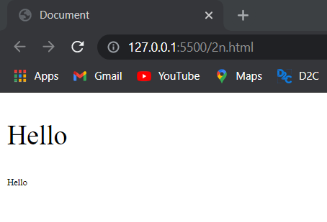

**o.**

**CODE**

<!DOCTYPE html>

<html lang="en">

<head>

    <meta charset="UTF-8">

    <meta http-equiv="X-UA-Compatible" content="IE=edge">

    <meta name="viewport" content="width=device-width, initial-scale=1.0">

    <title>Document</title>

</head>

<body>

    <marquee>Gaurav Kumar Singh</marquee>

</body>

</html>

**SCREENSHOTS**

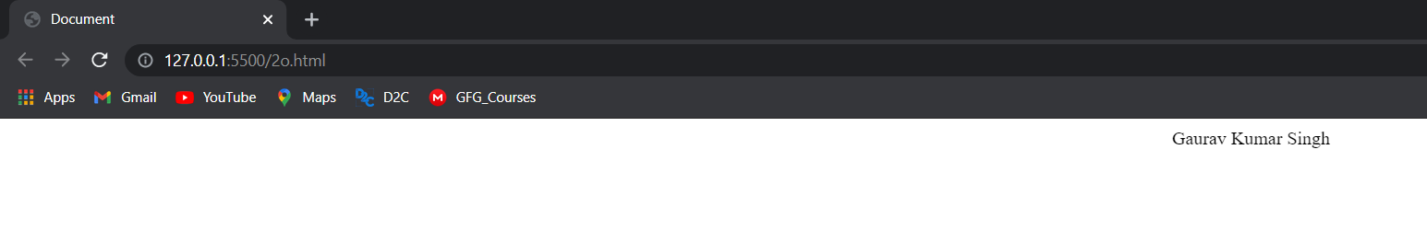

**p.**

**CODE**

<!DOCTYPE html>

<html lang="en">

<head>

    <meta charset="UTF-8">

    <meta http-equiv="X-UA-Compatible" content="IE=edge">

    <meta name="viewport" content="width=device-width, initial-scale=1.0">

    <title>Document</title>

</head>

<body>

    <p>This paragraph

        contains a lot of lines

        in the source code,

        but the browser

        ignores it.

    </p>

</body>

</html>

**SCREENSHOTS**

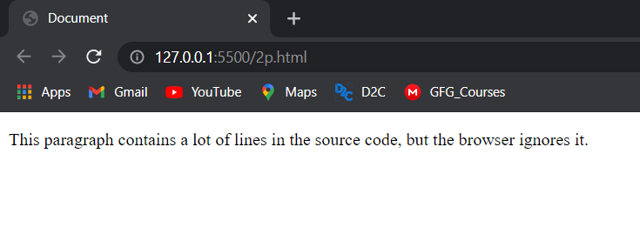

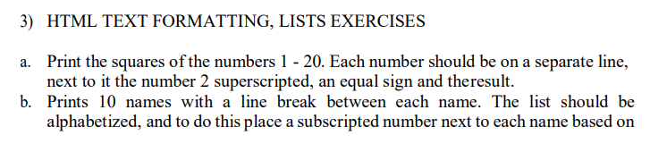 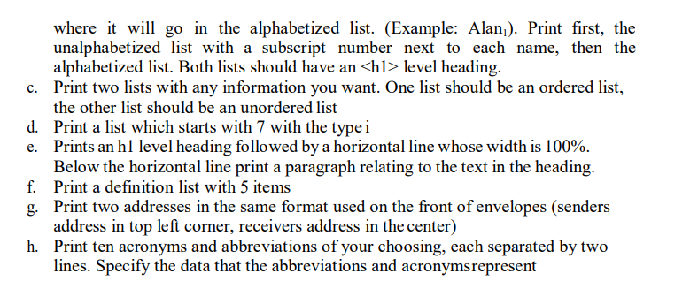

**a.**

**CODE**

<!DOCTYPE html>

<html lang="en">

<head>

    <meta charset="UTF-8">

    <meta http-equiv="X-UA-Compatible" content="IE=edge">

    <meta name="viewport" content="width=device-width, initial-scale=1.0">

    <title>Document</title>

</head>

<body>

    <p> 1<sup>2</sup> = 1</p>

    <p> 2<sup>2</sup> = 4</p>

    <p> 3<sup>2</sup> = 9</p>

    <p> 4<sup>2</sup> = 16</p>

    <p> 5<sup>2</sup> = 25</p>

    <p> 6<sup>2</sup> = 36</p>

    <p> 7<sup>2</sup> = 49</p>

    <p> 8<sup>2</sup> = 64</p>

    <p> 9<sup>2</sup> = 81</p>

    <p> 10<sup>2</sup> = 100</p>

    <p> 11<sup>2</sup> = 121</p>

    <p> 12<sup>2</sup> = 144</p>

    <p> 13<sup>2</sup> = 169</p>

    <p> 14<sup>2</sup> = 196</p>

    <p> 15<sup>2</sup> = 225</p>

    <p> 16<sup>2</sup> = 256</p>

    <p> 17<sup>2</sup> = 289</p>

    <p> 18<sup>2</sup> = 324</p>

    <p> 19<sup>2</sup> = 361</p>

    <p> 20<sup>2</sup> = 400</p>

</body>

</html>

**SCREENSHOTS**

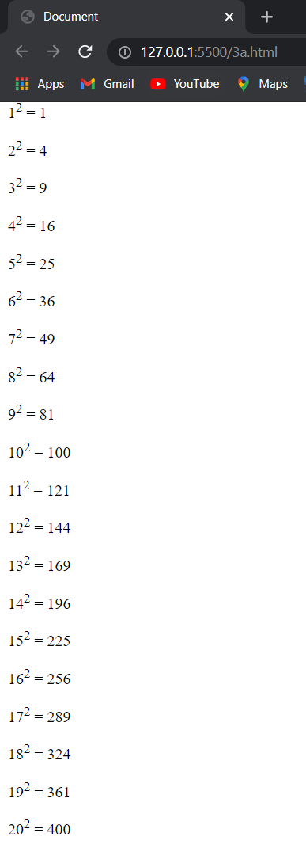

**b.**

**CODE**

<!DOCTYPE html>

<html lang="en">

<head>

    <meta charset="UTF-8">

    <meta http-equiv="X-UA-Compatible" content="IE=edge">

    <meta name="viewport" content="width=device-width, initial-scale=1.0">

    <title>Document</title>

</head>

<body>

    <h1>Unalphabetized List</h1>

    <ul>

        <li>Chinmay<sub>3</sub></li>

        <li>Dhruv<sub>4</sub></li>

        <li>Jaisper<sub>10</sub></li>

        <li>Gaurav<sub>7</sub></li>

        <li>Birbal<sub>2</sub></li>

        <li>Illeana<sub>9</sub></li>

        <li>Emma<sub>5</sub></li>

        <li>Farhan<sub>6</sub></li>

        <li>Harry<sub>8</sub></li>

        <li>Ayush<sub>1</sub></li>

    </ul>

    <h1>Alphabetized List</h1>

    <ul>

        <li>Ayush</li>

        <li>Birbal</li>

        <li>Chinmay</li>

        <li>Dhruv</li>

        <li>Emma</li>

        <li>Farhan</li>

        <li>Gaurav</li>

        <li>Harry</li>

        <li>Illeana</li>

        <li>Jaisper</li>

    </ul>

</body>

</html>

**SCREENSHOTS**

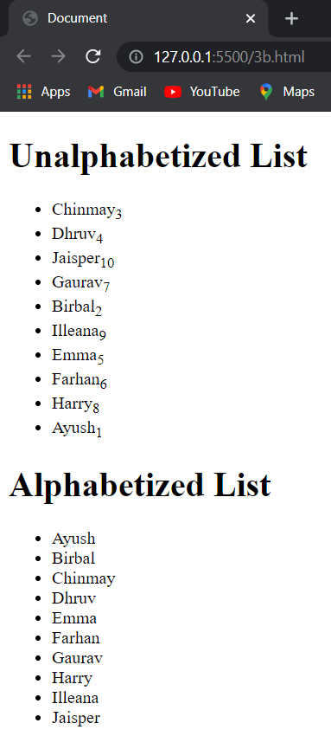

**c.**

**CODE**

<!DOCTYPE html>

<html lang="en">

<head>

    <meta charset="UTF-8">

    <meta http-equiv="X-UA-Compatible" content="IE=edge">

    <meta name="viewport" content="width=device-width, initial-scale=1.0">

    <title>Document</title>

</head>

<body>

    <ol>

        <li>A</li>

        <li>B</li>

        <li>C</li>

        <li>D</li>

        <li>E</li>

        <li>F</li>

        <li>G</li>

    </ol>

    <ul>

        <li>A</li>

        <li>B</li>

        <li>C</li>

        <li>D</li>

        <li>E</li>

        <li>F</li>

        <li>G</li>

    </ul>

</body>

</html>

**SCREENSHOTS**

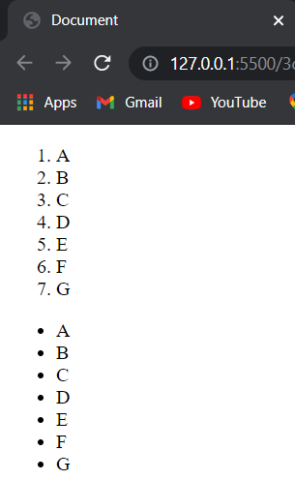

**d.**

**CODE**

<!DOCTYPE html>

<html lang="en">

<head>

    <meta charset="UTF-8">

    <meta http-equiv="X-UA-Compatible" content="IE=edge">

    <meta name="viewport" content="width=device-width, initial-scale=1.0">

    <title>Document</title>

</head>

<body>

    <ol reversed type='i'>

        <li></li>

        <li></li>

        <li></li>

        <li></li>

        <li></li>

        <li></li>

        <li></li>

    </ol>

    <ol start=7 type='i'>

        <li></li>

        <li></li>

        <li></li>

        <li></li>

        <li></li>

        <li></li>

        <li></li>

    </ol>

</body>

</html>

**SCREENSHOTS**

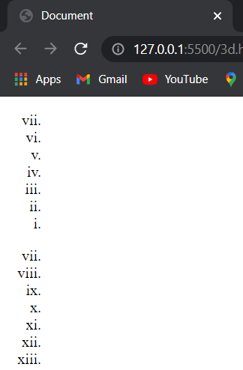

**e.**

**CODE**

<!DOCTYPE html>

<html lang="en">

<head>

    <meta charset="UTF-8">

    <meta http-equiv="X-UA-Compatible" content="IE=edge">

    <meta name="viewport" content="width=device-width, initial-scale=1.0">

    <title>Document</title>

</head>

<body>

    <h1>HTML</h1>

    <hr width="100%" />

    <p>The HyperText Markup Language, or HTML is the standard markup language for documents designed to be displayed in a web browser. It can be assisted by technologies such as Cascading Style Sheets (CSS) and scripting languages such as JavaScript.</p>

</body>

</html>

**SCREENSHOTS**

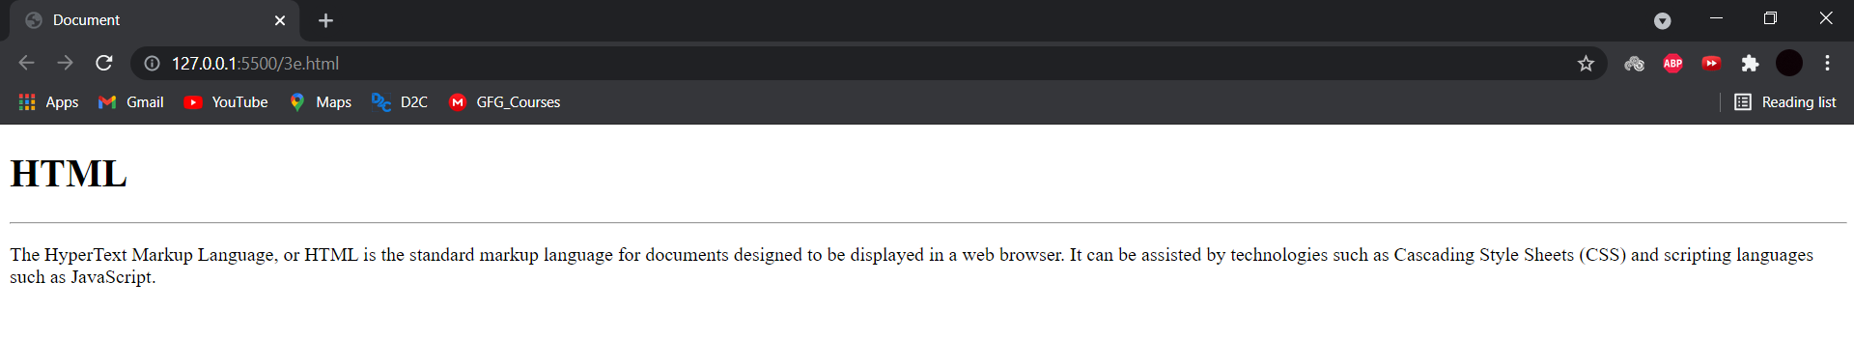

**f.**

**CODE**

<!DOCTYPE html>

<html lang="en">

<head>

    <meta charset="UTF-8">

    <meta http-equiv="X-UA-Compatible" content="IE=edge">

    <meta name="viewport" content="width=device-width, initial-scale=1.0">

    <title>Document</title>

</head>

<body>

    <dl>

        <dt>HTML</dt>

        <dd>Hyper Text Markup Language</dd>

        <dt>CSS</dt>

        <dd>Cascading Style Sheets</dd>

        <dt>JS</dt>

        <dd>JavaScript</dd>

    </dl>

</body>

</html>

**SCREENSHOTS**

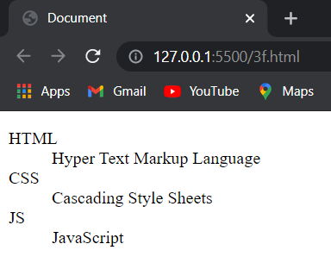

**g.**

**CODE**

<!DOCTYPE html>

<html lang="en">

<head>

    <meta charset="UTF-8">

    <meta http-equiv="X-UA-Compatible" content="IE=edge">

    <meta name="viewport" content="width=device-width, initial-scale=1.0">

    <title>Document</title>

</head>

<body>

    <address>

    601, Harshal Bldg,<br /> 7 Bunglows, Raheja Complex,<br />lokhandwala, Andheri (west)<br />mumbai

    </address>

    <br />

    <center>

    <address>

    33 1st Floor,<br /> Neelam Flyover<br />Delhi

    </address>

    </center>

</body>

</html>

**SCREENSHOTS**

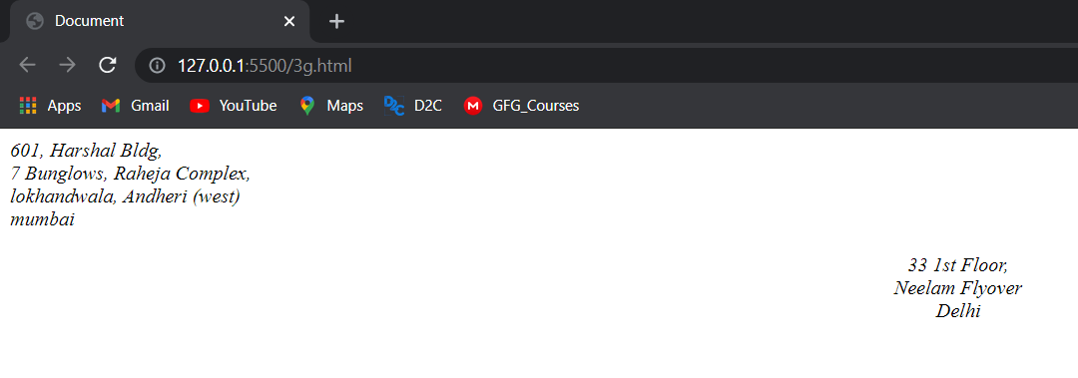

**h.**

**CODE**

<!DOCTYPE html>

<html lang="en">

<head>

    <meta charset="UTF-8">

    <meta http-equiv="X-UA-Compatible" content="IE=edge">

    <meta name="viewport" content="width=device-width, initial-scale=1.0">

    <title>Document</title>

</head>

<body>

    <abbr title="Abbreviation">Abbr.</abbr><br />

    <abbr title="Example">Ex.</abbr><br />

    <abbr title="Information">Info.</abbr><br />

    <abbr title="Paragraph">Para.</abbr><br />

    <abbr title="Acronyms">Acro.</abbr><br />

    <acronym title="Vellore Institute of Technology">VIT</acronym><br />

    <acronym title="Web Technologies">WT</acronym><br />

    <acronym title="Hypertext Markup Language">HTML</acronym><br />

    <acronym title="Cascading Style Sheets">CSS</acronym><br />

    <acronym title="JavaScript">JS</acronym>

</body>

</html>

**SCREENSHOTS**

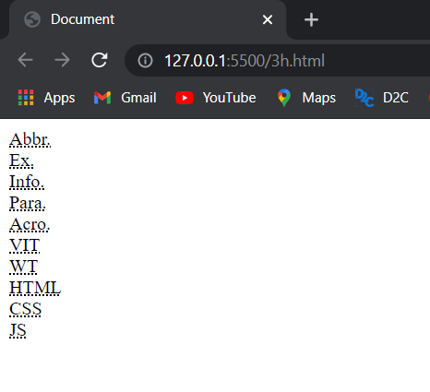

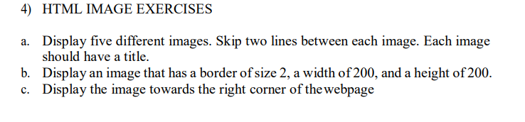

**a.**

**CODE**

<!DOCTYPE html>

<html lang="en">

<head>

    <meta charset="UTF-8">

    <meta http-equiv="X-UA-Compatible" content="IE=edge">

    <meta name="viewport" content="width=device-width, initial-scale=1.0">

    <title>Document</title>

</head>

<body>

    <img src="./Bot_Icon.jpg" title="Test Image" alt="Test Image" width="50" height="60"><br /><br />

    <img src="./HTML.jpg" title="HTML" alt="HTML" width="50" height="60"><br /><br />

    <img src="./CSS.jpg" title="CSS" alt="CSS" width="50" height="60"><br /><br />

    <img src="./JS.jpg" title="JavaScript" alt="JavaScript" width="50" height="60"><br /><br />

    <img src="./FullStack.jpg" title="FullStack Development" alt="FullStack Development" width="50" height="60"><br /><br />

</body>

</html>

**SCREENSHOTS**

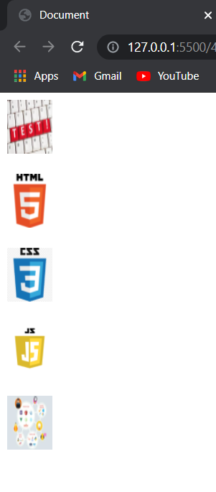

**b.**

**CODE**

<!DOCTYPE html>

<html lang="en">

<head>

    <meta charset="UTF-8">

    <meta http-equiv="X-UA-Compatible" content="IE=edge">

    <meta name="viewport" content="width=device-width, initial-scale=1.0">

    <title>Document</title>

</head>

<body>

    <img src="./Bot_Icon.jpg" border=2 title="Test Image" alt="Test Image" width="200" height="200"><br /><br />

</body>

</html>

**SCREENSHOTS**

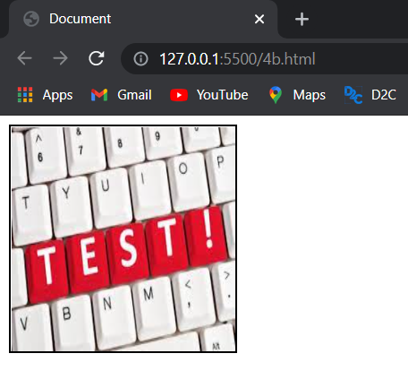

**c.**

**CODE**

<!DOCTYPE html>

<html lang="en">

<head>

    <meta charset="UTF-8">

    <meta http-equiv="X-UA-Compatible" content="IE=edge">

    <meta name="viewport" content="width=device-width, initial-scale=1.0">

    <title>Document</title>

</head>

<body>

    <img src="./Bot_Icon.jpg" align=right title="Test Image" alt="Test Image" width="200" height="200"><br /><br />

</body>

</html>

**SCREENSHOTS**

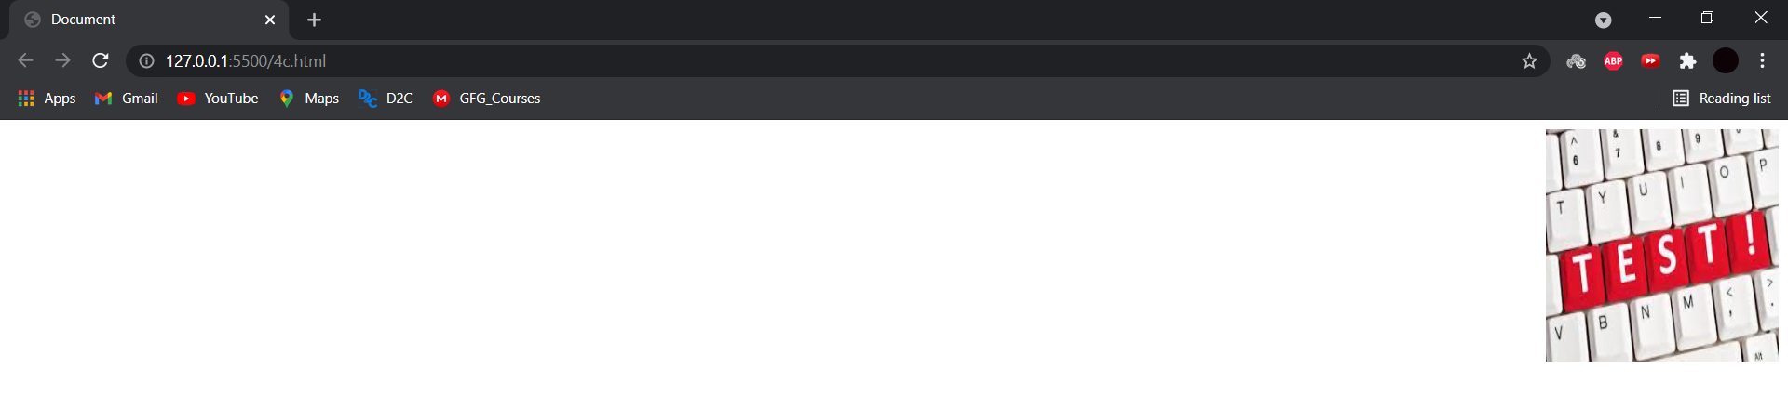

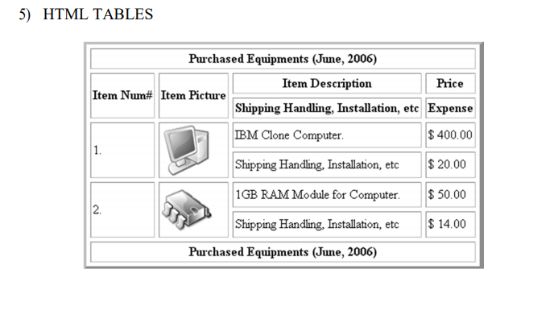

**CODE**

<!DOCTYPE html>

<html lang="en">

<head>

    <meta charset="UTF-8">

    <meta http-equiv="X-UA-Compatible" content="IE=edge">

    <meta name="viewport" content="width=device-width, initial-scale=1.0">

    <title>Document</title>

    <style>

        table, th, td {

            border: 1px solid black;

            border-collapse: collapse;

        }

        th{

            padding: 5px;

        }

        </style>

</head>

<body>

    <table>

        <tr>

            <th colspan=4>Purchased Equipments (June, 2006)</th>

        </tr>

        <tr>

            <th rowspan=2>Item Num#</th>

            <th rowspan=2>Item Picture</th>

            <th>Item Description</th>

            <th>Price</th>

        </tr>

        <tr>

            <th>Shipping Handling, Installation, etc</th>

            <th>Expense</th>

        </tr>

        <tr>

            <th rowspan=2>1.</th>

            <th rowspan=2><img src="./IBM_clone_computer.jpg" title="IBM Clone Computer" alt="IBM Clone Computer" width="80" height="80"></th>

            <th>IBM Clone Computer.</th>

            <th>$ 400.00</th>

        </tr>

        <tr>

            <th>Shipping Handling, Installation, etc</th>

            <th>$ 20.00</th>

        </tr>

        <tr>

            <th rowspan=2>2.</th>

            <th rowspan=2><img src="./RAM_module.jpg" title="1GB RAM Module for Computer" alt="1GB RAM Module for Computer" width="80" height="80"></th>

            <th>1GB RAM Module for Computer.</th>

            <th>$ 50.00</th>

        </tr>

        <tr>

            <th>Shipping Handling, Installation, etc</th>

            <th>$ 14.00</th>

        </tr>

    </table>

</body>

</html>

**SCREENSHOTS**

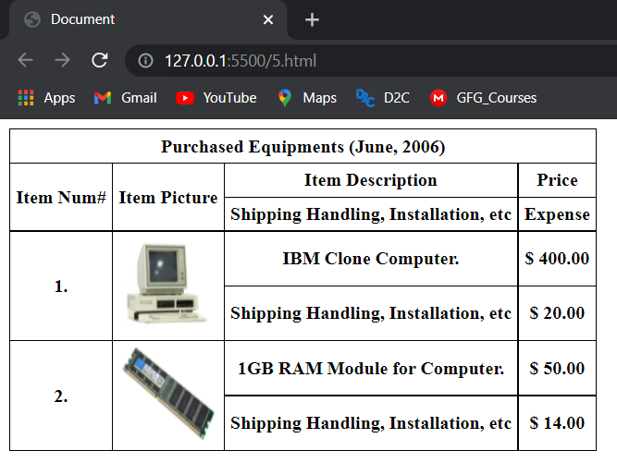

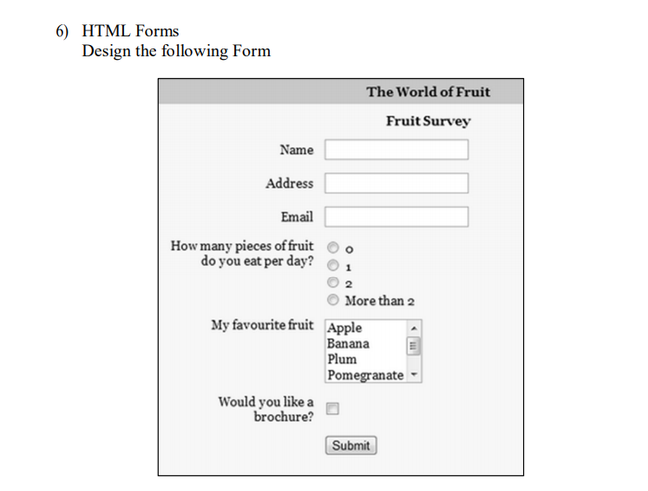

**CODE**

<!DOCTYPE html>

<html lang="en">

<head>

    <meta charset="UTF-8">

    <meta http-equiv="X-UA-Compatible" content="IE=edge">

    <meta name="viewport" content="width=device-width, initial-scale=1.0">

    <title>6</title>

</head>

<body>

    <form align="center">

        <div><b>The world of Fruit Survey</b></div>

        <div><b>Fruit Survey</b></div><br>

        <label for="fname">Name</label>

        <input type="text" id="name" name="name"><br><br>

        <label for="address">Address</label>

        <input type="text" id="address" name="address"><br><br>

        <label for="email">Email</label>

        <input type="email" id="name" name="name"><br><br>

        <p><b>How many pieces of fruit do you eat per day?</b></p>

        <input type="radio" id="fruit" name="fruit" value="0">

        <label for="fruit">0</label><br>

        <input type="radio" id="fruit" name="fruit" value="1">

        <label for="fruit">1</label><br>

        <input type="radio" id="fruit" name="fruit" value="2">

        <label for="fruit">2</label><br>

        <input type="radio" id="fruit" name="fruit" value="more than 2">

        <label for="fruit">more than 2</label><br><br>

        <label for="fav">My favourite fruit</label>

        <select id="fav" name="fav" size="3">

            <option value="volvo">Apple</option>

            <option value="saab">Banana</option>

            <option value="fiat">Plum</option>

            <option value="audi">Pomegranate</option>

        </select><br><br>

        <label for="check">Would you like a brochure?</label>

        <input type="checkbox" id="check" name="check" value="yes">

    </form>

</body>

</html>

**SCREENSHOTS**

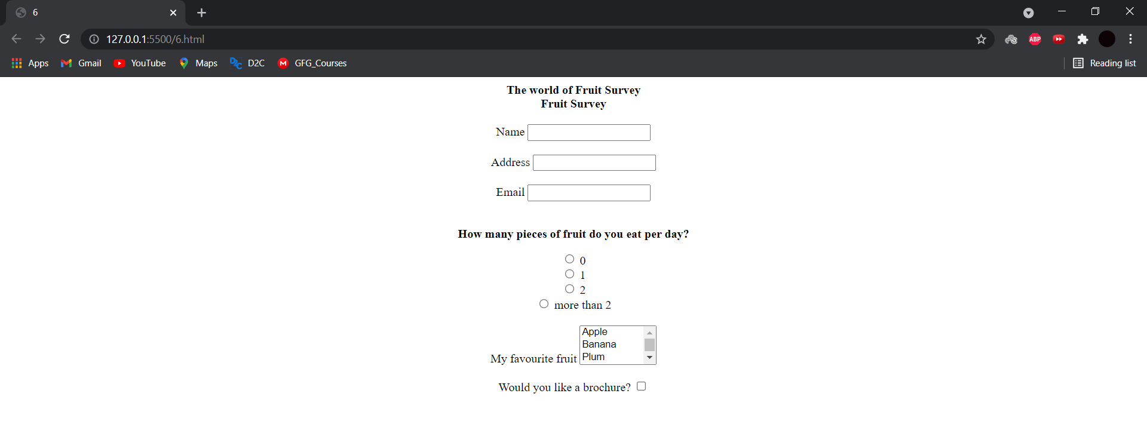

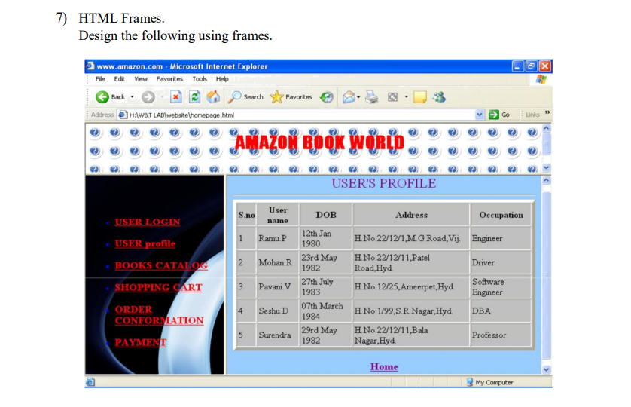

**CODE MAIN FILE**

<!DOCTYPE html>

<html lang="en">

<head>

    <meta charset="UTF-8">

    <meta http-equiv="X-UA-Compatible" content="IE=edge">

    <meta name="viewport" content="width=device-width, initial-scale=1.0">

    <title>Document</title>

    <style>

        h1{

            position:absolute;

            margin-left:40%;

            margin-top:-100px;

            text-align: center;

            color:red;

            opacity:1.0;

        }

        .heading{

            height:70px;

            margin:10px 0px;

            padding:40px 0px;

            background-image: url("CSS.jpg");

            background-size: 50px 50px;

            opacity:0.5;

        }

    </style>

</head>

<body>

    <div class=heading></div>

    <h1>AMAZON BOOK WORLD</h1>

    <div style="height:700px;">

        <iframe src="7x2.html" style="height:60%; width:25%; float:left; margin-left:30px"></iframe>

        <iframe src="7x1.html" style="height:60%; width:70%; float:right;"></iframe>

    </div>

</body>

</html>

**CODE FRAME 1 FILE**

<!DOCTYPE html>

<html lang="en">

<head>

    <meta charset="UTF-8">

    <meta http-equiv="X-UA-Compatible" content="IE=edge">

    <meta name="viewport" content="width=device-width, initial-scale=1.0">

    <title>Document</title>

    <style>

        body{

            background-color:rgb(167, 255, 226);

            z-index: -1;

        }

        h2{

            margin-left:40%;

            margin-bottom: 50px;

        }

        .xh{

            font-weight: bold;

        }

        table{

            background-color:white;

            margin:auto;

            width:80%;

            border: 1px solid black;

        }

        tr{

            width:max-content;

            border: 1px solid black;

        }

        td{

            background-color:rgb(185, 185, 185);

            padding:5px;

            text-align: center;

            border: 1px solid black;

        }

    </style>

</head>

<body>

    <h2>USER PROFILE</h2>

    <table>

        <th>

            <td class=xh>User name</td>

            <td class=xh>DOB</td>

            <td class=xh>Address</td>

            <td class=xh>Occupation</td>

        </th>

        <tr>

            <td>1.</td>

            <td>Ramu P</td>

            <td>12th Jan 1980</td>

            <td>M.G Road, Vij</td>

            <td>Engineer</td>

        </tr>

        <tr>

            <td>2.</td>

            <td>Mohan R</td>

            <td>23rd May 1982</td>

            <td>Patel Road, Vij</td>

            <td>Driver</td>

        </tr>

        <tr>

            <td>3.</td>

            <td>Pavani V</td>

            <td>27th July 1983</td>

            <td>Ameerpet, Vij</td>

            <td>Software Engineer</td>

        </tr>

        <tr>

            <td>4.</td>

            <td>Seshu D</td>

            <td>07th March 1984</td>

            <td>S.R Nagar, Hyd</td>

            <td>DBA</td>

        </tr>

        <tr>

            <td>5.</td>

            <td>Surendra</td>

            <td>29th May 1982</td>

            <td>Bala Nagar, Hyd</td>

            <td>Professor</td>

        </tr>

    </table>

    <h3 style="margin-left:45%"><a href="#">HOME</a></h3>

</body>

</html>

**CODE FRAME 2 FILE**

<!DOCTYPE html>

<html lang="en">

<head>

    <meta charset="UTF-8">

    <meta http-equiv="X-UA-Compatible" content="IE=edge">

    <meta name="viewport" content="width=device-width, initial-scale=1.0">

    <title>Document</title>

    <style>

        ul{

            margin-top: 35px;

            margin-bottom: 35px;

        }

        body{

            background-image: linear-gradient(to bottom, rgba(102, 255, 0, 0.5), rgba(255, 255, 255, 0.5), rgba(0, 255, 76, 0.5));

            background-repeat: no-repeat;

            background-size: 100% 100%;

        }

        li{

            margin-top: 10px;

            margin-bottom: 10px;

            font-size:larger;

            font-weight:bolder;

        }

        a{

            color:red;

        }

        a:hover{

            color:blue;

        }

    </style>

</head>

<body>

    <ul>

        <li><a href="#">USER LOGIN</a></li><br>

        <li><a href="#">USER profile</a></li><br>

        <li><a href="#">BOOKS CATALOGUE</a></li><br>

        <li><a href="#">SHOPPING CART</a></li><br>

        <li><a href="#">ORDER CONFIRMATION</a></li><br>

        <li><a href="#">PAYMENT</a></li><br>

    </ul>

</body>

</html>

**SCREENSHOTS**

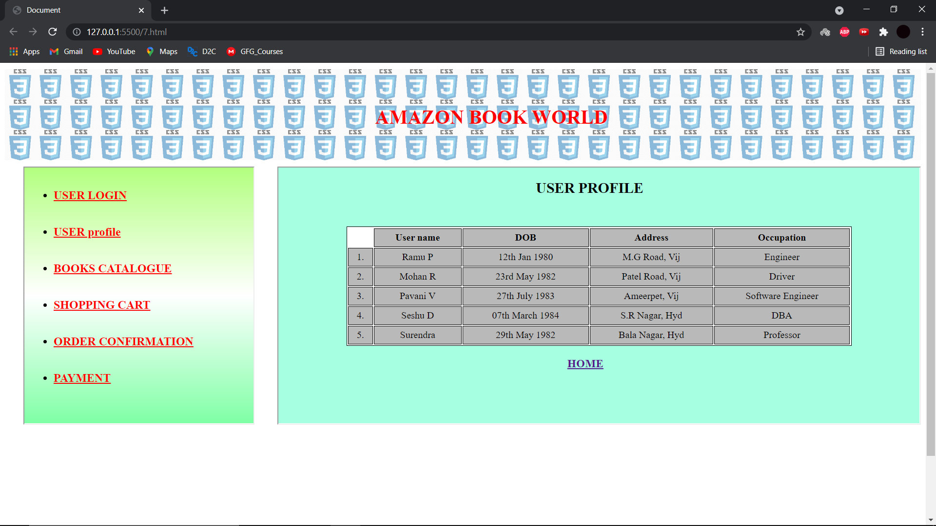 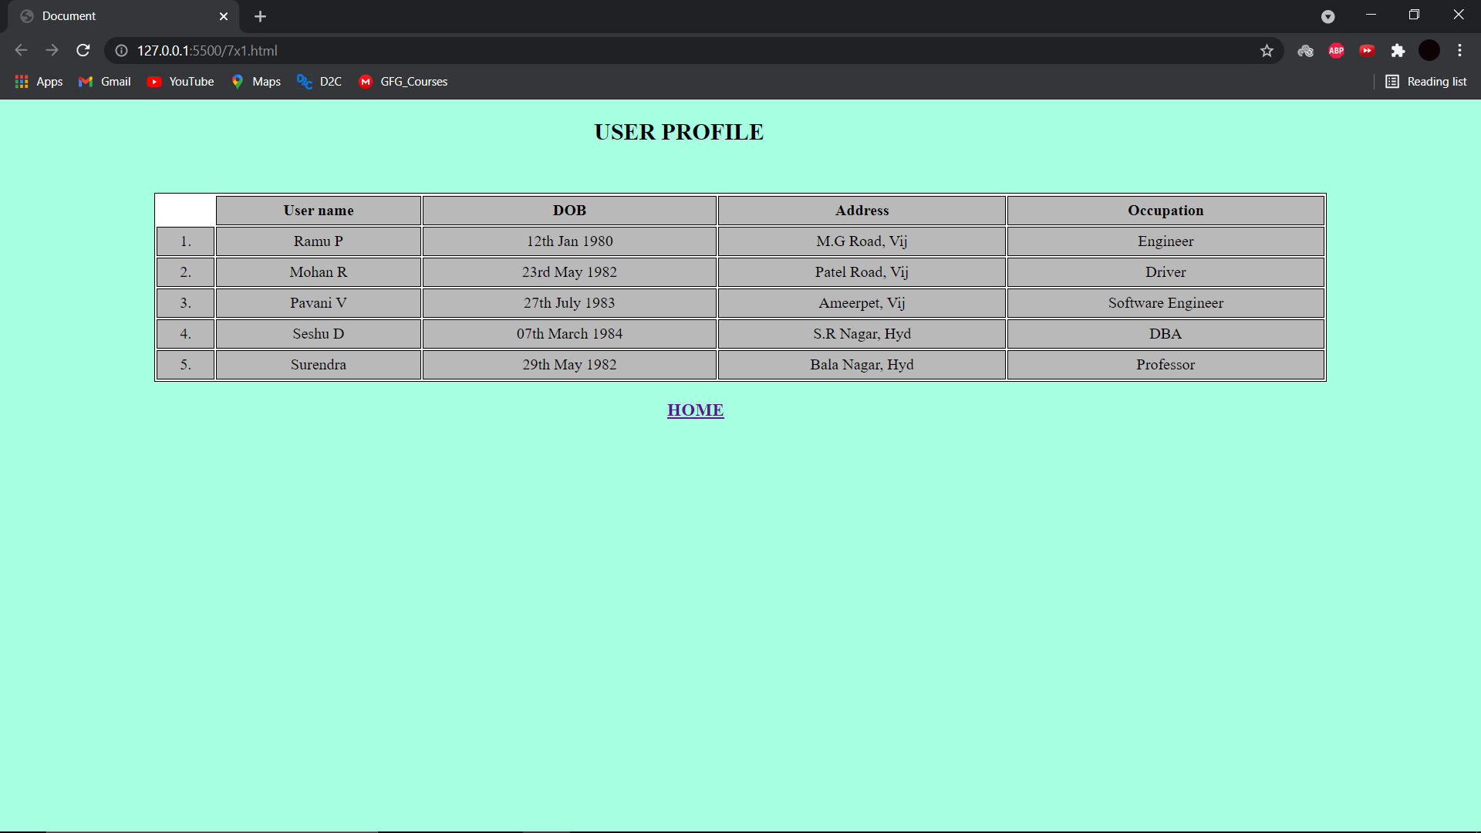

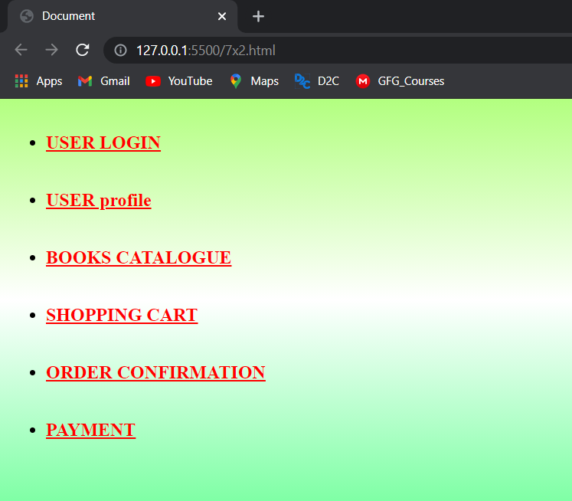

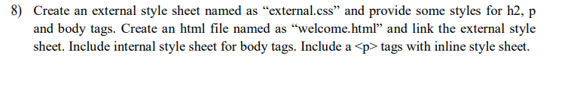 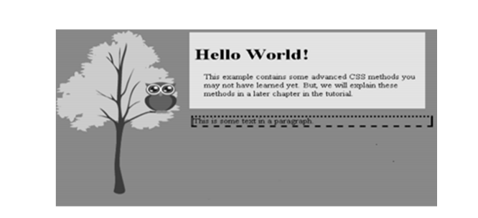

**CODE**

**HTML**

<!DOCTYPE html>

<html lang="en">

<head>

    <meta charset="UTF-8">

    <meta http-equiv="X-UA-Compatible" content="IE=edge">

    <meta name="viewport" content="width=device-width, initial-scale=1.0">

    <title>Document</title>

    <link href="external.css" rel="stylesheet">

    <style>

        body{

            background-color: gray;

        }

    </style>

</head>

<body>

    <div class="container">

        <div class="main">

            <h2 style="padding-left:10px;">Hello World!</h2>

            <p style="font-size: 18px; font-family: 'Courier New', Courier, monospace; padding-left:40px;">The example contains some advanced CSS methods you may

                not have learned yet. But, we will explain these methods

                in a later chapter in the tutorial.

            </p>

        </div>

        <div class="box">

            <p style="font-size: 18px; font-family: 'Courier New', Courier, monospace; font-weight: bold;">This is some text in a paragraph.</p>

        </div>

    </div>

</body>

</html>

**CSS**

.container{

    margin-top: 40px;

    margin-right: 50px;

    height:100px;

    width:600px;

    float: right;

}

.main{

    background-color: lightgray;

    padding: 5px;

}

.box{

    margin-top: 8px;

    border: 7px solid black;

    border-style: dotted solid dashed double;

}

**SCREENSHOTS**

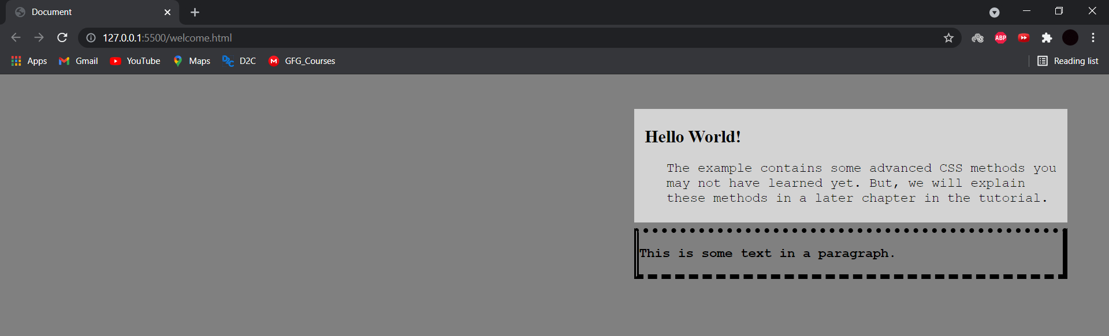

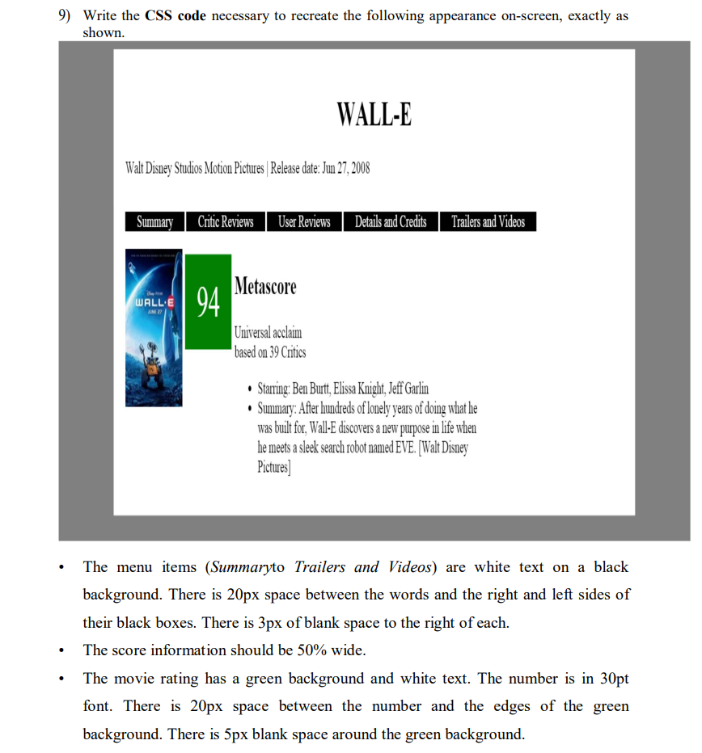 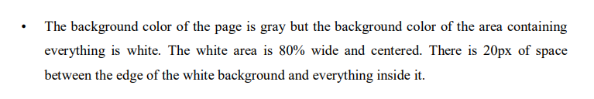

**CODE**

**HTML**

<!DOCTYPE html>

<html lang="en">

<head>

    <meta charset="UTF-8">

    <meta http-equiv="X-UA-Compatible" content="IE=edge">

    <meta name="viewport" content="width=device-width, initial-scale=1.0">

    <title>Document</title>

    <link rel="stylesheet" href="9.css">

</head>

<body>

    <h1>WALL-E</h1>

    <p>Walt Disney Studios Motion Pictures | Release date: Jun 27, 2008</p>

    <div class=flex-container>

        <div>Summary</div>

        <div>Critic Reviews</div>

        <div>User Reviews</div>

        <div>Details and Credits</div>

        <div>Trailers and Videos</div>

    </div>

    <div class="inline-blocked par">

        <div class="inline-blocked walleimg"><img src="Bot_Icon.jpg"></div>

        <div class="inline-blocked score-text"><p>94</p></div>

    </div>

    <div class="inline-blocked score-info">

        <h2>Metascore</h2>

        <p>Universal acclaim</p>

        <p>based on 39 critics</p>

        <ul>

            <li><p>Starring: Ben Burtt, Elissa Knight, Jeff Garlin</p></li>

            <li>Summary: After hundreds of lonely years of doing what he was biolt for, Wall-E discovers a new purpose in life when he meets a sleek search robot EVE. [Walt Disney Pictures]</li>

        </ul>

    </div>

</body>

</html>

**CSS**

h1{

    text-align:center;

}

p{

    margin: -2px 0px;

}

.flex-container{

    display:flex;

    flex-direction:row;

    flex-wrap: wrap;

}

.flex-container div{

    margin-top:40px;

    background-color:black;

    color:white;

    padding: 0px 20px;

    margin-right: 3px;

}

.inline-blocked{

    display:inline-block;

}

.walleimg img{

    height:150px;

    width:100px;

}

.score-text{

    font-size:30px;

    padding:20px;

    background-color:green;

    margin:5px;

    margin-bottom: auto;

    vertical-align:top;

    color:white;

}

.par{

    margin-top: 20px;

    vertical-align:top;

}

.score-text p{

    display:table-cell;

    vertical-align:middle;

}

.score-info{

    margin-left:5px;

    width:50%;

    margin-top:25px;

}

**SCREENSHOTS**

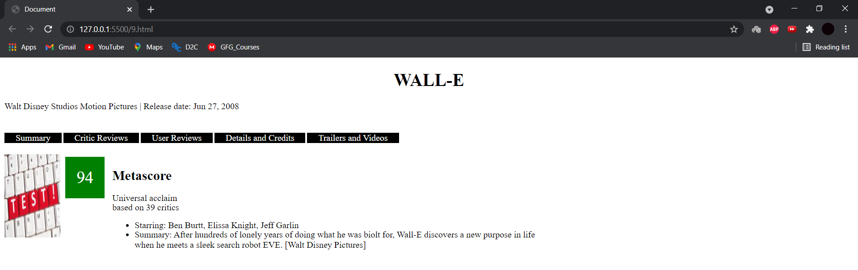

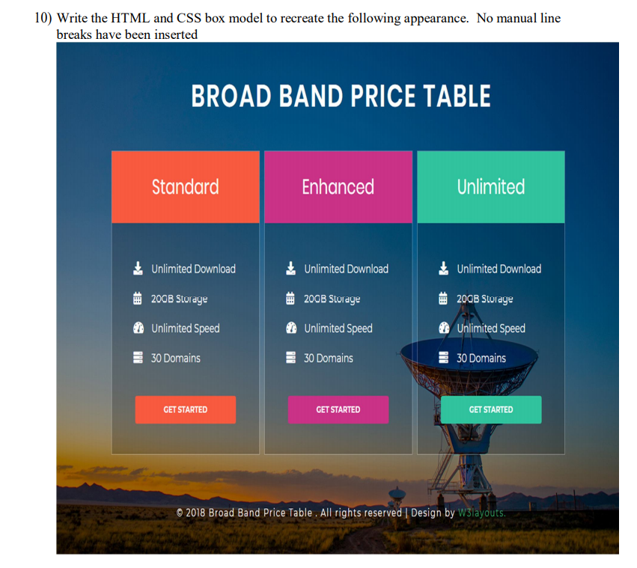

**CODE**

**HTML**

<!DOCTYPE html>

<html lang="en">

<head>

    <meta charset="UTF-8">

    <meta http-equiv="X-UA-Compatible" content="IE=edge">

    <meta name="viewport" content="width=device-width, initial-scale=1.0">

    <title>Document</title>

    <link rel="stylesheet" href="10.css">

</head>

<body>

    <h1>BROAD BAND PRICE TABLE</h1>

    <div class="parent">

        <div class="standard">

            <div class="category1 cat">STANDARD</div>

            <div class="det">

                <p>Unlimited Download</p>

                <p>20 GB Storage</p>

                <p>Unlimited Download</p>

                <p>30 Domains</p>

            </div>

            <button class="a">GET STARTED</button>

        </div>

        <div class="enhanced">

            <div class="category2 cat">ENHANCED</div>

            <div class="det">

                <p>Unlimited Download</p>

                <p>20 GB Storage</p>

                <p>Unlimited Download</p>

                <p>30 Domains</p>

            </div>

            <button class="b">GET STARTED</button>

        </div>

        <div class="unlimited">

            <div class="category3 cat">UNLIMITED</div>

            <div class="det">

                <p>Unlimited Download</p>

                <p>20 GB Storage</p>

                <p>Unlimited Download</p>

                <p>30 Domains</p>

            </div>

            <button class="c">GET STARTED</button>

        </div>

    </div>

    <footer>Made By Gaurav Kumar Singh</footer>

</body>

</html>

**CSS**

body{

    background-image: url("BG.jpeg");

    background-repeat: no-repeat;

    background-size:cover;

}

.parent{

    position:relative;

    display:flex;

    flex-wrap: no-wrap;

    justify-content:center;

}

.standard{

    width:300px;

    height:auto;

    background-color:rgba(0, 0, 0, 0.35);

    margin-right:10px;

}

.enhanced{

    width:300px;

    height:auto;

    background-color:rgba(0, 0, 0, 0.35);

}

.unlimited{

    width:300px;

    height:auto;

    background-color:rgba(0, 0, 0, 0.35);

    margin-left:10px;

}

.category1{

    background-color:rgb(255, 96, 34);

    text-align:center;

}

.a{

    background-color:rgb(255, 96, 34);

}

.category2{

    background-color:rgb(219, 41, 175);

    text-align:center;

}

.b{

    background-color:rgb(219, 41, 175);

}

.category3{

    background-color:rgb(38, 158, 146);

    text-align:center;

}

.c{

    background-color:rgb(38, 158, 146);

}

.cat{

    padding: 30px 0px;

    font-size:20px;

    color:white;

}

.det{

    margin: 40px 0px 40px 80px;

    color:white;

}

h1{

    margin:60px 0px;

    color:white;

    text-align:center;

}

footer{

    color:white;

    text-align:center;

    margin-top:100px;

}

button{

    margin-left:21%;

    margin-bottom: 10px;

    height:40px;

    padding:0px 40px;

    color:white;

    font-weight: bolder;

}

**SCREENSHOTS**

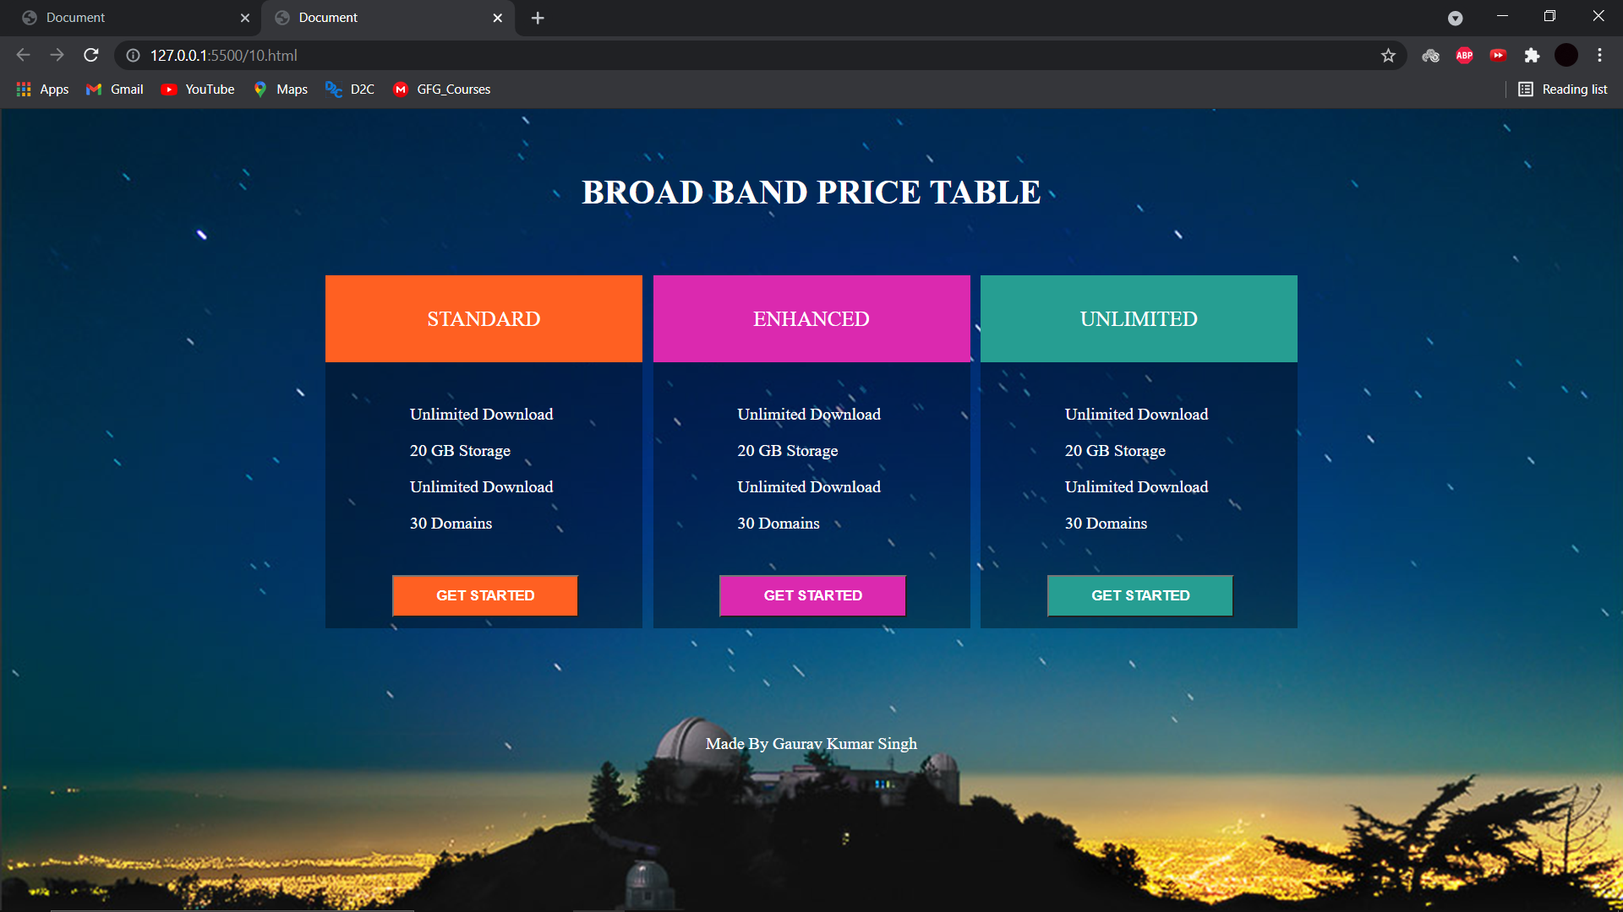

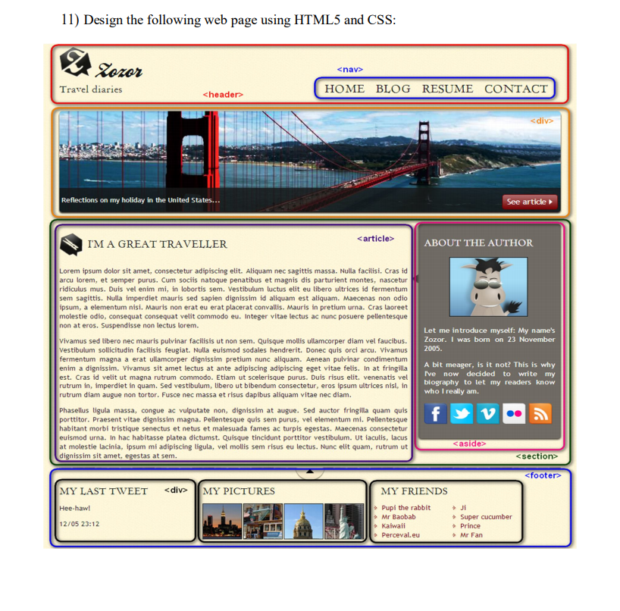

**CODE**

**HTML**

<!DOCTYPE html>

<html lang="en">

<head>

    <meta charset="UTF-8">

    <meta http-equiv="X-UA-Compatible" content="IE=edge">

    <meta name="viewport" content="width=device-width, initial-scale=1.0">

    <title>Document</title>

    <link rel="stylesheet" href="11.css">

</head>

<body>

    <header>

        <img src="HTML.jpg" class="logo">

        <h2>ZOZOR</h2>

        <p class=navdesc>Travel Diaries</p>

        <nav>

            <a href="#">HOME</a>

            <a href="#">BLOG</a>

            <a href="#">RESUME</a>

            <a href="#">CONTACT</a>

        </nav>

    </header>

    <div>

        <img src="BG.jpeg" class="introimg">

        <div class=introdiv>

            Reflections on my holiday in the United States <button class=introa>See article</button>

        </div>

    </div>

    <section>

        <article>

            <h3>I'M A GREAT TRAVELER</h3>

            <p>Lorem ipsum dolor sit amet, consectetur adipiscing elit. Pellentesque urna mi, ultrices non tempor in, bibendum in augue. Etiam at sem at odio pellentesque auctor. Praesent faucibus, nisl vel varius gravida, dolor dolor sagittis sem, eget rhoncus arcu elit vel felis. Nullam ultricies odio sollicitudin venenatis consectetur. Nulla facilisi. Lorem ipsum dolor sit amet, consectetur adipiscing elit. Sed odio tellus, facilisis a purus ut, luctus tincidunt nisl. Quisque et tincidunt nunc. Vestibulum efficitur luctus mattis.</p>

            <p>Sed eget enim dapibus, tincidunt arcu quis, feugiat quam. Ut facilisis est ac magna efficitur, ut malesuada sapien placerat. Nam eu nulla ante. Sed sed laoreet justo, iaculis fringilla purus. Nullam lobortis massa eu hendrerit laoreet. Proin iaculis nisi quam, at auctor elit varius ut. Vivamus feugiat bibendum viverra. Nunc posuere arcu eu mi ultrices porttitor. Nullam in elit lacus. Aliquam vitae scelerisque velit.</p>

            <p>Nam aliquam placerat mauris. Maecenas non velit aliquet est volutpat ornare. Suspendisse potenti. Praesent vitae nisi aliquet, malesuada magna in, iaculis felis. Pellentesque ac venenatis est. Aliquam mollis nunc quis mauris tincidunt ultrices. Nulla luctus nibh eget ligula rutrum maximus. Praesent nunc eros, aliquet eu justo nec, aliquam vulputate ipsum. Donec ut quam sollicitudin, porttitor sapien in, convallis leo. Suspendisse euismod, eros non semper scelerisque, leo eros euismod urna, a hendrerit mi sem nec leo. Fusce nec eleifend risus, ac mollis elit. Proin dapibus erat justo, quis vehicula nulla vestibulum vitae. Aliquam at sem quis augue tempor dignissim. Class aptent taciti sociosqu ad litora torquent per conubia nostra, per inceptos himenaeos.</p>

        </article>

        <aside>

            <h3>ABOUT THE AUTHOR</h3>

            <img src="CSS.jpg">

            <p>

                Let me introduce myself. My name's ZOZOR. I was born on 23 November 2005.

            </p>

            <p>

                A bit meager, is it not? This is why I've now decided to write my biography to let my readers know who i really am.

            </p>

            <div class=asidiv>

                <a href="#">FB</a>

                <a href="#">Twitter</a>

                <a href="#">VK</a>

                <a href="#">LinkedIn</a>

            </div>

        </aside>

    </section>

    <footer>

        <div class="x tweet">

            <h3>MY LAST TWEET</h3>

            <p>Hee-haw!</p>

            <p>12/05 23:12</p>

        </div>

        <div class="x  pictures">

            <h3>MY PICTURES</h3>

            <div>

                <img src="JS.jpg">

                <img src="JS.jpg">

                <img src="JS.jpg">

                <img src="JS.jpg">

            </div>

        </div>

        <div class="x friends">

            <h3>MY FRIENDS</h3>

            <ul>

                <li>Pupi the rabbit</li>

                <li>Mr Baobab</li>

                <li>Kaiwaii</li>

                <li>Parceval.eu</li>

            </ul>

            <ul>

                <li>Ji</li>

                <li>Super cucumber</li>

                <li>Prince</li>

                <li>Mr Fan</li>

            </ul>

        </div>

    </footer>

</body>

</html>

**CSS**

nav{

    margin:0px 5px;

    display:block;

    float:right;

    margin-top:40px;

}

h2{

    display:inline-block;

    vertical-align:top;

    margin-top:12px;

}

.logo{

    margin:10px;

    width:30px;

    height:30px;

}

header{

    height:60px;

    border: 3px solid black;

    border-radius: 10px;

}

.navdesc{

    display:inline-block;

    position:absolute;

    margin-left:-126px;

    margin-top:40px;

}

.introimg{

    margin-top:10px;

    width:100%;

    height:150px;

    border: 3px solid black;

    border-radius: 20px 20px 0px 0px;

}

.introdiv{

    width:95%;

    background-color:rgba(0, 0, 0, 0.4);

    height:28px;

    color:white;

    position: absolute;

    margin-top:-35px;

    margin-left:2.5%

}

.introa{

    margin-top:-5px;

    float:right;

    background-color: rgb(136, 15, 15);

    color:white;

    font-weight:800

}

article{

    display:inline-block;

    text-align:justify;

    width:65%;

    border:3px solid black;

    padding:10px;

    border-radius: 10px;

}

aside{

    background-color:grey;

    color:white;

    border:3px solid black;

    width:30%;

    float:right;

    padding:10px 5px 20px 5px;;

    border-radius: 10px;

}

aside img{

    width:60%;

    height:100px;

    display: block;

    margin-left: auto;

    margin-right: auto;

}

aside p{

    text-align:justify;

}

.asidiv{

    display:flex;

    flex-wrap: wrap;

    justify-content:space-around

}

.asidiv a{

    display:block;

}

footer{

    display:flex;

    justify-content:space-around;

    flex-wrap:nowrap;

    /* border:3px solid black;

    margin-top:10px; */

}

.x{

    margin-top: 10px;

    width:30%;

    height:150px;

    border:3px solid black;

    border-radius: 10px;

    margin:10px;

}

.tweet{

    padding-left:10px;

}

.friends h3{

    position:relative;

    left:40px

}

.friends{

    padding-left: 10px;

}

.friends ul{

    display:inline-block;

    margin-top:-3px;

    justify-content: space-around;

    color:rgb(136, 15, 15);

}

.friends ul:nth-child(1){

    float:left;

    padding-left: 50px;

}

.friends ul:nth-child(2){

    float:right;

    padding-right: 150px;

}

.pictures{

    padding: 0px 10px;

}

.pictures div{

    display:flex;

    justify-content:space-around;

    flex-wrap:nowrap;

}

.pictures div img{

    width:20%;

    height:80px;

    border:2px solid black;

    border-radius: 10px;

}

body{

    background-color:rgb(255, 243, 220);

}

.x h3{

    color:rgb(0, 77, 0);

}

**SCREENSHOTS**

